
SYSTEMS DIVISION

CTM-I

Application Architecture

DRAFT

Prepared By:

Eddie Horvath
Bruce Currie
Jim Moss
Nigel Phillips
Indravadan Merai

November 5, 2005

(/tmp/lo/0000.doc)

Contents

1.0 Introduction 5
    - 1.0. Business Drivers 5
    - 1.1. Technology Drivers 5
    - 1.2. Overview 5
1.1 Use Case View 6
1.1.1 Trade Match Login 6
1.1.2 My Trade Match 6
1.1.3 Trade Maintenance 6
1.1.4 Firm Maintenance 6
1.1.5 Batch Utilities 6
1.1.6 RTC 6
1.1.7 Matching 6
1.1.8 Application Support 7
1.1.9 Security 7
    - 1.3. Logical Packages 14
1.1.10 Client Services 14
1.1.11 Common Services 16
1.1.12 Business Services 17
1.1.13 Infrastructure Services 18
    - 1.4. Processing Paradigm 19
1.1.14 Foundation Framework 19
1.1.15 Batch 19
1.1.16 Internet 19
1.2 Process View 20
1.3 Deployment View 21
    - 1.5. Process Deployment 21
    - 1.6. Processing Needs (Application Layer) 22
1.1.17 Performance 22
1.1.18 Availability/Reliability 22
1.1.19 Migration 22
    - 1.7. Data Needs (Information Layer) 22
1.1.20 Physical Location 22
    - 1.8. Hardware Installation 22
    - 1.9. Third-Party Products 23
    - 1.10. Software Installations 23
    - 1.11. Maintenance 23

Foreword

The application architecture is a blueprint for what the developers will build. Like a building blueprint, it outlines the major features both physical and functional. It details the type of hardware, if not the specific hardware. It outlines the dimensions of the architecture by specifying the boundaries. It builds-in any required security, capacity, performance, maintenance, and operational needs. It specifies all external and user interfaces to the application. The application architecture is the vision for what the built system should look like. Although the architecture may change slightly over time, it gives the designers and developers a view of what the final product should be.

Scope

The application architecture covers the high level view of the final system. It will provide the vision for other more detailed documents. It will cover both the logical, physical and functional aspects of the application. Although the application architecture is not enough for a developer to begin building the application, it is necessary for providing a common vision and determining synchronization points for multiple teams.

Audience

The system owner should read this document to ensure it captures the owner’s vision for functionality and presentation. The system architect should read this document to ensure it adheres to the enterprise architectural vision and philosophy. The information architect should read this document to ensure it properly captures the business functionality. The infrastructure architect should read the document to ensure that the application uses the infrastructure items wherever possible. The technology architect should read this document to ensure the application properly uses the appropriate technologies. The system engineer should read this document to understand the vision and constraints placed on the system. The system engineer will reference this document when building the system requirements and performing system analysis. The designer should read this document to ensure his design captures the architect’s intent. The developer should read this document to ensure the implementation realizes the architect’s vision of the application.

Prerequisites

Readers should be familiar with the system architecture, the information architecture, the infrastructure architecture, and the technology architecture for this project.

Organization

- The Introduction section contains background information, the business driver force and the technical driver force for the system, and an overview of the system context.

- The Use Case View section provides the motive and describes the system needs in concrete terms.

- The Logical View section describes the static and dynamic aspect of the system in terms of packages, subsystems, components, and their responsibilities.

- The Process View section represents the decomposition of components in terms of execution flows. Process View also represents the synchronization between the components and the availability and reliability of them at the process level.

- The Deployment View section describes how the processes are deployed at the processor level. It discusses the scalability and fault tolerance features of the system. The hardware and software tools are also documented here.

Introduction

This document addresses the application architecture of CBOE Trade Match Firm Interfaces (CTM-I) project to support the distributed enhancements and webified capabilities associated with the deployment of the new CTM-I GUI interface.

Business Drivers

CBOE Trade Match System (CTM) provides access to member firms, clearing members and brokers in support of their need to modify their trade activity. This system is being developed in conjunction with CBOE Trade Match Server development as a means to reduce operating cost and provide a more consistence platform for further development.

Technology Drivers

With the growing popularity of the Internet and n-tier applications, the support for client-Server applications is dwindling. The CBOE management also wants to standardize development and use a common technology to develop applications across the board. The CBOE Trade Match Firm Interfaces system will primarily be developed as an Internet based application using the CBOE Direct development model. The system will be developed using Struts as the front-end tool to render web pages communicating with Business Services developed using Foundation Framework.

Overview

The CTM Rewrite Project, WR #2213, will reduce the dependency on the MVS operating environment by migration of the CTM core system to a UNIX based platform. The strategy for the CTM Rewrite Project, WR #2213, was to reduce this dependency on the MVS operating environment without impact to the current Firm interfaces.

There are currently three methods that the firms electronically interface with CBOE through the MVS environment: RTC, 3270 ITP Terminal, and RJE/NJE data transmission. The Enhanced Firm Interfaces Project expands on the CTM Rewrite Project, and further reduces the dependency on the MVS operating environment by eliminating these dependencies on MVS and providing the firms with interfaces to CTM through a new architectural approach.
.

Use Case View

Trade Match Login

My Trade Match

Trade Maintenance

Trade Query

Trade Allocation

Trade Entry

Trade Message Browse

Trade Message Correction

Trade Message Inquiry

Futures Trade Query

Futures Trade Correction

Futures Trade Release

Futures Trade Allocation

Firm Maintenance

Firm Authorization

Firm Statistics

ORS Correspondent

Firm Description

Firm TCP/IP Socket Password Maintenance

Batch Utilities

Report Selection

Wire Authorizations

Batch Load

Class Information

Wire Delete

RTC

Drop Copy Maintenance

TCP/IP Re-Send

Matching

Status Display

Tier Match Maintenance

Control Update Maintenance

Batch Match Maintenance

Range Deletes

Application Support

Parameter Browse

Generic Parameter Add

Generic Parameter Maintenance

Parameter Definition Browse

Parameter Definition Edit

Dynamic Parameter Browse

Dynamic Parameter Edit

Dynamic Parameter Add

Back-Door Futures Delete

Back-Door Futures Resend

Options Audit Query

Internal Switch Maintenance

Miscellaneous Jobs

Debug Logging Control

Security

User Maintenance

Logical View

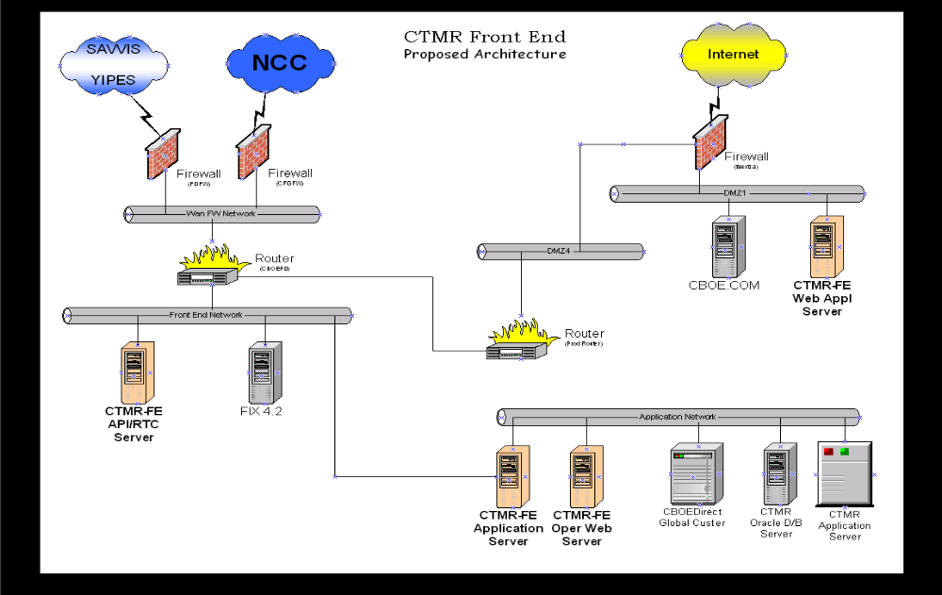

The CTM-I system will be comprised of the following five logical packages of functionality
- Client Services (MVC Struts, Jetty)
- Common Services (Application Security Management Services)
- CTM-R Services
- Infrastructure Services
- Foundation Framework Services
- Adapter

The Client Services will be based on the MVC Model containing view, model and controller components. These allow the interaction of the client interface with the system and vice versa. The presentation services also contain the Jetty service responsible for receiving http requests and forwarding it to the MVC classes.

The common services are services that are used by both the client and the business services. The main component is the Application Security Management service.

The CTM-R Services are services that will be used to validate trade data on the CTM-R server. The CTM-R server is the main component for exposing various business objects and rules.

Infrastructure Services constitutes the various infrastructure services that CBOE Direct built to support security, logging and various other functionality.

The Security adapter will be responsible for propagating the user updates to the Security Admin Service. The adapter is discussed in detail in the security architecture.

Diagram below are the detailed logical components of the CTM-I system.
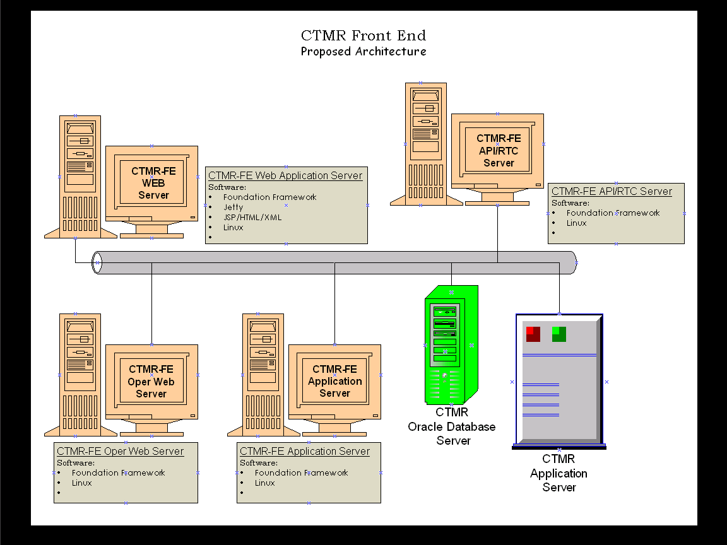

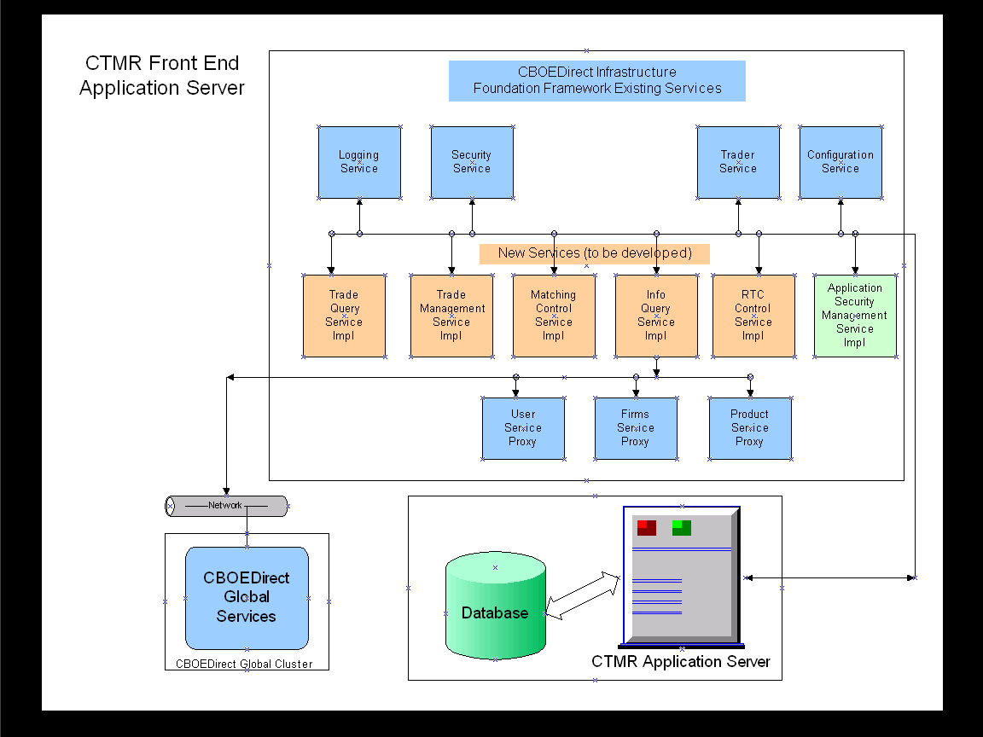

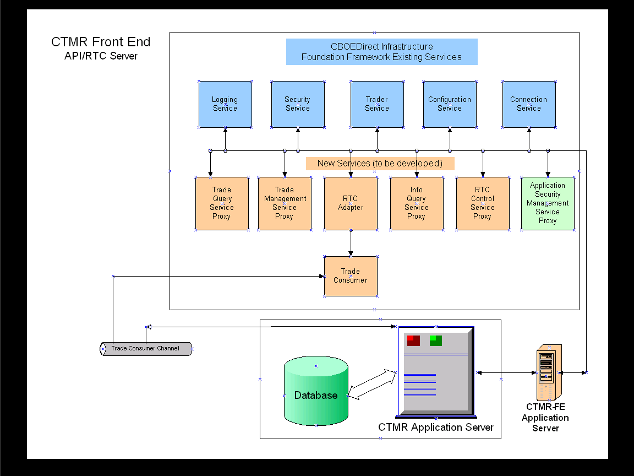

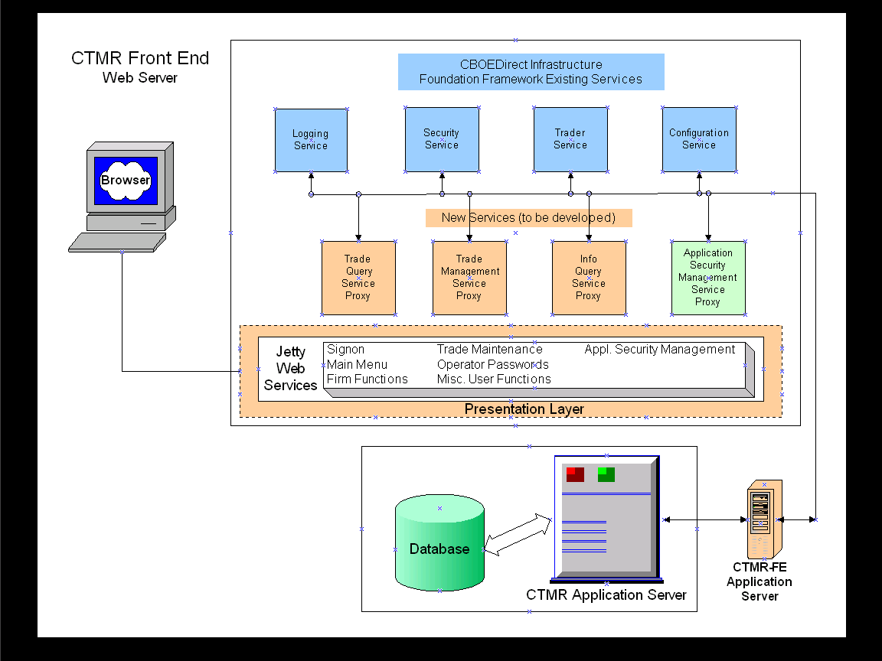

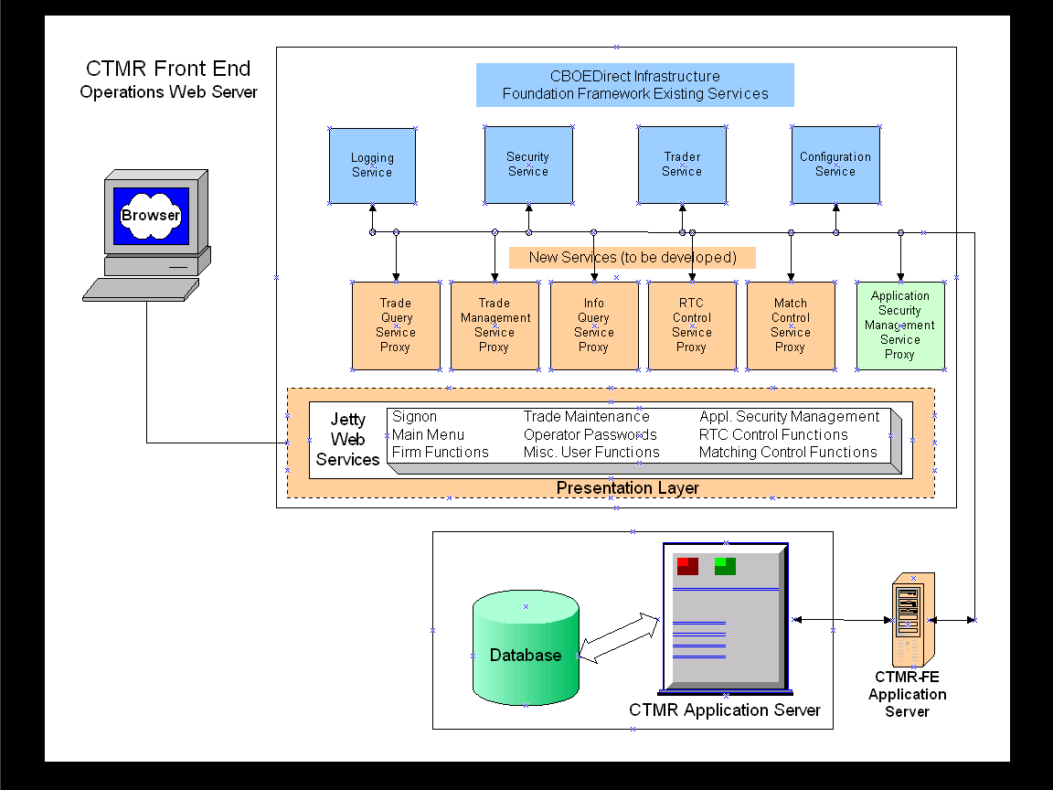

Logical Packages

Client Services

The Client Services contains the MVC Struts Classes

MVC Struts Classes

When the Struts ActionServlet receives a request from Jetty, it runs the request through a gauntlet that processes the locale, mapping, form bean and finally the action. Each use case in the system has an associated Controller Class, View Class and a model class. The model classes communicate with the business services to query and update information based on user requests.

View
(Form Classes)

Controller
(Action Classes)

Model
(Model classes)

Business Services

Jetty Service

Browser
Application

The following are the sets of MVC classes that are used to display the GUI

- Login
- Welcome
- Trade Query
- Trade Allocation
- Trade Correction
- Trade Message
- Message Maintenance
- Futures Trade Query
- Futures Trade Correction
- Futures Trade Allocation
- Futures Trade Release
- Trade Entry
- Firm Maintenance
- Firm Authorization
- Firm TCP/IP Password
- Firm Statistics
- ORS Correspondent Conversion
- Batch Utilities
- Wire Authorization
- Batch Load
  - Batch Delete
- RTC
- Drop Copy
  - Drop Copy Add
- TCP/IP Resend
- Matching
- Status Display
- Tier Match
- Control Update
- Batch Match
- Application Support
- Parameter Browse
- Parameter Edit
- Log Control
- Audit Query
- Internal Switch Maintenance
- Backdoor Futures Delete
- Backdoor FUO
- Range Delete
- Security
- User Maintenance

Common Services

Application Security Management Service

Application Security Management Service (ASMS) is responsible for both client and business service security. ASMS has two major responsibilities

- Security Manager

- ASMS will validate the user ID and password with the security Service
- ASMS will provide client menu access based on the roles that a user ID belongs to

- Session Manager

- ASMS will maintain a memory mapping of HTTP Session ID, User ID, Security Session ID, roles and last access time
- ASMS will provide the security session ID if the HTTP Session ID is supplied
- ASMS will time out sessions that have been idle for a business defined period

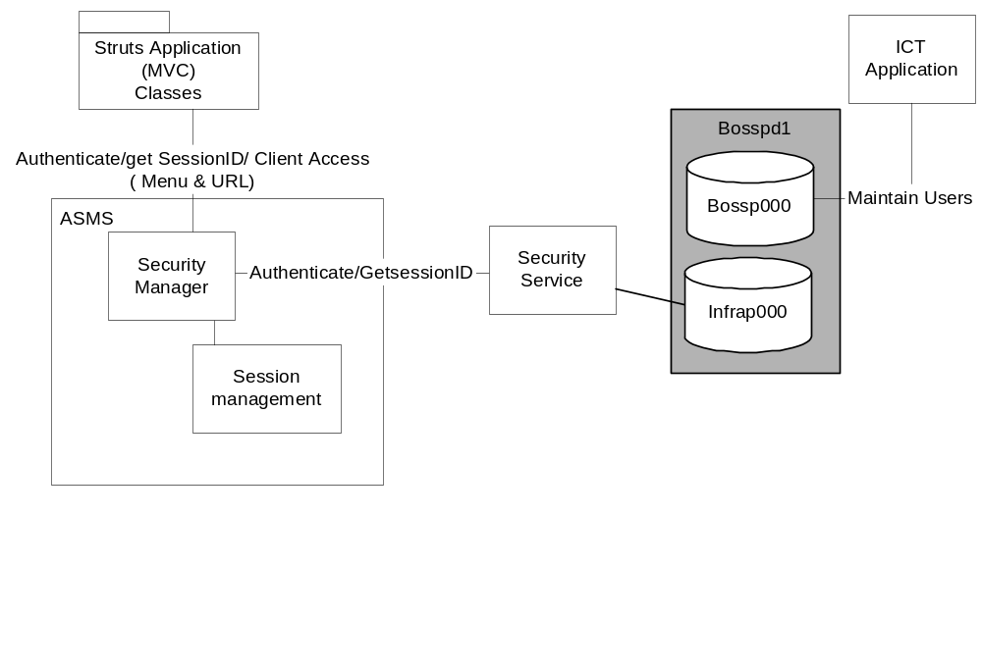

Business Services

Futures Trade Service

The Futures Trade Service is responsible for maintaining futures trade information. Access to trades will be provided by CTM-R services.

Firm Maintenance Service

Firm Maintenance Service is responsible for providing access and maintenance abilities to all firm related functions. Those functions are:

- Firm Statistics
- Maintenance to:
  - Authorized Firms
  - Contact Information
  - ORS CMTA Conversion List
  - TCP/IP Passwords

Access to this data will be provided by CTM-R services.

RTC Service

RTC Service is used to update and resend trades to firms via RTC/IP. This service allows an Application Support person to selectively resend trade data, using a specific range, to an RTC/IP firm destination. This service allow a firm user to update their RTC/IP password.

Batch Utility Service

Batch Utility Service is responsible for providing our Trading Operations user’s with the functionally needed to monitor and adjust trade data processed in a batch mode.

Parameter Service

Parameter Service is responsible for access to maintain specific parameters used throughout the CTM-R system. These parameters control the flow of the system and other critical functions. Access to this service will be limited to only Application Support personal.

Options Trade Service

Options Trade Services is responsible for providing access to add and maintain to trade data stored on CTM-R databases. This service provides:

- Access to add, update or delete trades.
- Selected users have the ability to allocate trades.
- CBOE users can delete trades within specific ranges.

User Maintenance Service

User Maintenance Service provides access to add and update specific user information.

Trade Message Service

Trade Message Service is responsible for maintaining and displaying messages generated by the systems. These messages can be either informational, system warning or fatal trades message due to editing errors. This service provides access to this information and in specific situations, adjustments can be made to fatal trades.

Infrastructure Services

The infrastructure services provided by CBOE Direct will be re-used. The following are some of the services that Insider Trading System uses

- Security Service
- Logging Service
- Systems Management Service
- Persistence Service

Jetty Services

Jetty Web Server will be bundled into a service by the infra structure group. This service will be instantiated as part of our business service. The Jetty is a Java HTTP Server and Servlet Container. When the browser posts a request, Jetty uses Jasper service to translate the jsp file into java code. Jetty also acts as a container hosting the Struts ActionServlet. When the path of the request matches the servlet context in the ActionServlet, the jetty container forwards the request to the ActionServlet.

Processing Paradigm

This section describes the common processing paradigm using software design patterns.

Foundation Framework

The Foundation Framework is an application server framework, consisting of a set of Java classes developed by CBOE Direct, which enables using infrastructure services in a consistent and effective manner for both the Application Service developers and Business Service developers. All the business services will be developed using the Foundation framework. JGrinder will be primarily used for all transaction management (except Integrated Case Tracking Service) and access to all persisted data stores.

Batch

CTM-I system is for the most part an online reporting and management system. Most of the reports produced by the system are based on data generated by batch processing done throughout the trading day. The batch process is a Unix shell scripts (managed by CTM-R) that run throughout the day to produce specific (matched & unmatched) reports to be disseminated to our user.

Internet

The client for the CTM-I system will be browser-based application using jetty web server and struts MVC model.

Process View

Trade Match Server

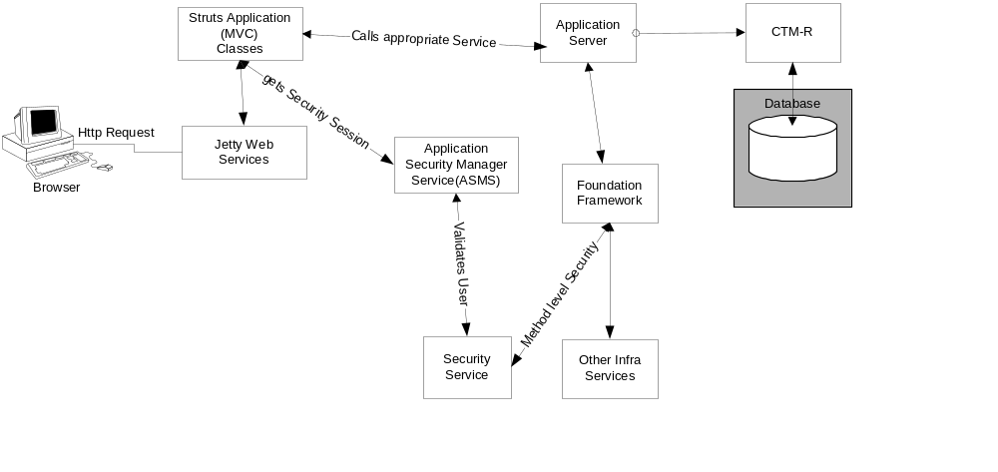

- When the user submits a http request to the application server, the application server sends the request to jetty service.
- The Jetty web service forwards the call to Struts ActionServlet
- The struts ActionServlet will forward the call to the appropriate controller class in the struts MVC framework which would then forward it to Model
- The model class in the struts MVC would then call the ASMS to validate the user session
- ASMS on successful validation with infrastructure security service will maintain a memory map of the jetty HTTP session ID, User ID and security service session ID and return back a success message.
- The model class will then call the corresponding Application service on our Application Server.
- The Application Service will invoke the security service through the foundation framework façade to verify method level access
- If the user has the appropriate rights then the business service will communicate with the database and return to the struts MVC classes the results
- The struts MVC classes will then render the results appropriately in the browser

Deployment View

Process Deployment
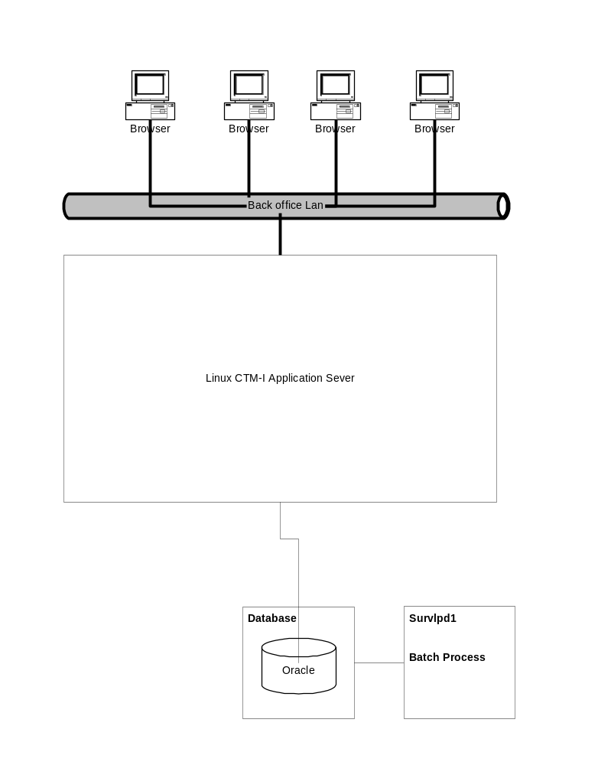

Processing Needs (Application Layer)

Performance

CTM-I system will be implemented as a three-tier application. The user interface will be a thin client browser with the web service sitting outside the firewall. The web server consist of a cluster of machines thereby allowing for load balancing between the two servers. All request will be deployed to the Application Server, where these request will be processed and dispatched to the appropriate service for processing. In the event data is needed, the request will be dispatched to CTM-R for processing.

The initial number of user will be limited, but it expected the growth will continue until all the mainframe users (300) migrated over. The Linux server hosting the web service and business service will be capable of handling the load. CTM-I system is built using the Foundation framework. This provides the additional flexibility to deploy the system as N-tier if performance becomes vital.

Availability/Reliability

The CTM-I system will be deployed on two Linux servers with fail over capabilities. The cold backup Linux machine will be used in the event that the primary Linux server goes down.

The Linux Server will have disk fail over and mirrored disks. If one of the disks fails, the other disk will be used as fallback.

In the event availability becomes an issue in the future, Foundation framework provides the flexibility to have master slave configurations.

Migration

All the interfaces between components will be versioned to ensure the migration between the iteration and phases of development. CTM-I services will be deployable with multiple versions. As far as deployment is concerned, each service and version comprises a unique deployable service.

Data Needs (Information Layer)

Physical Location

The data required for the CTM-I system will be stored in databases controlled by CTM-R.

Hardware Installation

A new Linux server will be deployed in production for the Insider Trading System. The Linux server will be added to the current PATROL to enable monitoring.

Third-Party Products

This section identifies the third-party products required by Insider Trading System

Java SDK, SDK for Enterprise
- Struts Tag Libraries
  - Jakarta Struts
  - Struts – Layout
  - Struts - Menu
- Jetty
- Linux
- Clear case
- IntellJ

Software Installations

[Describe the expected method of deploying the application into the operational environment. Define the media and format for deploying the system. For example, the application could be a Java JAR on a server that each client downloads and installs. Describe the state of the system before and after the software installation. Define any dependencies on hardware, third party software, or other applications.]

Maintenance

[Describe the approach for routine maintenance, such as software patches. Describe emergency maintenance procedures, such as backing out an installed version of the application to the previous version, due to some catastrophic errors in the software.]

